



Essay / Assignment Title:
Development of an End-to-End NLP Pipeline for Customer Feedback
Intelligence and Sentiment Driven Decision Support
Programme title:
MSc Artificial Intelligence - Module: Natural Language Processing
Name:
Mohammadreza Gheychivand
Year:
2026 October

CONTENTS

CONTENTS 2
Introduction and Dataset 4
Task 1: Preprocessing and Exploratory Analysis 5
Task 2 : Classical NLP Baseline for Sentiment or Complaint Classification 12
Task 3 : Semantic Embeddings for Feedback Retrieval and Similarity Analysis 16
Task 4 : Fine Tuning a Transformer for Sentiment or Feedback Classification 21
Task 5 : Responsible NLP for Customer Feedback Analytics, Risks and Mitigation 27
Conclusion 31
References 32
APPENDIX (if necessary) 35

Statement of compliance with academic ethics and the avoidance of plagiarism

I honestly declare that this dissertation is entirely my own work and none of its part has been copied from printed or electronic sources, translated from foreign sources and reproduced from essays of other researchers or students. Wherever I have been based on ideas or other people texts I clearly declare it through the good use of references following academic ethics.
(In the case that is proved that part of the essay does not constitute an original work, but a copy of an already published essay or from another source, the student will be expelled permanently from the postgraduate program).

Name and Surname (Capital letters):

Mohammadreza Gheychivand

Date: 10/07/2026

Introduction and Dataset

The target of this report is to create a complete pipline for NLP and for customer feedback intelligence. It means to transform the raw text of the clients to the informations that our company be able to use it. This project has been done on the tweets of clients of the American airlines and has five parts:
- preprocessing and exploratory analysis
- baseline classic with TF-IDF
- semantic embeddings
- fine-tuning the model DistilBERT
- analyze the responsible NLP

Our dataset is selected from “Twitter US Airline Sentiment” published by CrowdFlower in Kaggle. All of the tweets are about to big airlines inside the America and had been collected in February 2015. Annotators determined the sentiment first “positive, negative, or neutral” and then recorded the reason for the complaint “negative reason” for the negative tweets. This dataset is perfect for us because it is really and it’s the real voice of the clients, with short, noisy texts. They have the both sentiment and complaint reason as well.
Original file (dataset) have 14640 row and 15 column, 213 duplicate texts which has been left out, and there were 25 row with different lables also. After deleting it remains only 14427 tweets. And another thing that our classes here are imbalanced:
- negative: 9,080 (62.9%)
- neutral: 3,057 (21.2%)
- positive: 2,290 (15.9%)

For the model that always says “negative” we have the accuracy equals 0.629 for that model, but its F1 macro is just 0.257. for that reason we take the F1 macro as the main metric due to the fact that it give the all of the classes equal weight and not hiding the errors on the minority classes (Grandini, Bagli and Visani, 2020).
For a fair comparing, we created a fixed, stratified split with 3,000 for training, 1,000 for validation, and 1,000 for testing (seed always on 42). Tasks 2 through 4 all are using the same split. The model get selected on the validation set, while the test set is used just for final evaluation.
CrowdFlower (lisence: CC BY-NC-SA 4.0) Twitter US Airline Sentiment. Kaggle. Available at: https://www.kaggle.com/datasets/crowdflower/twitter-airline-sentiment (Accessed: 5 October 2026). Grandini, M., Bagli, E. and Visani, G. (2020) Metrics for multi-class classification: an overview. arXiv:2008.05756. Available at: https://arxiv.org/abs/2008.05756 (Accessed: 4 October 2026).

Task 1: Preprocessing and Exploratory Analysis

1.1 Loading, inspection and cleaning
The Tweets.csv file contains 14,640 rows and 15 columns; the sample tweets are full of mentions, hashtags, emojis and spelling errors. In 5,462 rows (37.3%) the negativereason column is empty, merely because only negative tweets are given a reason. We also identified 213 repeated texts, 25 of which have different labels, and kept only one copy of each, resulting in 14,427 tweets. Tweets that appear in both the training and the test sets make the results appear better than they actually are, so this step is important (Elangovan, He and Verspoor, 2021).
The CleaningTheTweets function carries out the initial cleaning by decoding HTML codes, replacing links with a single token (url), removing mentions and expanding short forms so that "don't" becomes "do not" with the negation remaining visible. The drawback is that emojis are lost, even though emojis are useful signals for sentiment classifiers (Palomino and Aider, 2022). To address this, we have also developed a more light cleaning procedure which preserves emojis and capital letters; this version is used for NER, for the embeddings and for DistilBERT. This approach is similar to what BERTweet does since it also replaces mentions and links with special tokens and converts emojis into text rather than deleting them (Nguyen, Vu and Nguyen, 2020).
1.2 Tokenisation, stop words and lemmatisation
In the case of one tweet, the tokenisers produced 12 tokens (with whitespace), 15 (using the NLTK TweetTokenizer), 17 (using spaCy) and 21 (using the NLTK Treebank). The Treebank performed the worst when handling tweets, for instance by splitting "@united" into two parts, which is why we decided to use the NLTK TweetTokenizer. The problem with stop words was more significant. The default lists consist of 198 words (in NLTK) and 326 (in spaCy), and both include negations. When the negations are removed, the sentence "The flight was not on time" becomes "flight time". We removed the negations, leaving 195 and 319 words respectively. Although general lists are often used without modification, specialised fields also have their own uninformative words (Sarica and Luo, 2021).
The Porter stemmer converts "was" into "wa", which isn't a valid word. The WordNet lemmatiser in NLTK regards a word as a noun unless it is given a different tag, so "lost" is changed to "lose" only when a verb tag is provided, and in our case we carried out a verb pass first. spaCy identifies the part of speech in the sentence and gives back "lose" and "be", although it also changes "better" to "well". Neither of these tools is clearly the better one. The more relevant question is actually whether lemmatisation is of any use at all. Palomino and Aider (2022) discovered that lemmatisation aids indexing but does not substantially improve sentiment analysis. Although we have not tested this ourselves, we use lemmas only for counting and theming and not for the classifiers (Palomino and Aider, 2022).
1.3 Named entity recognition and NLTK versus spaCy
The smaller English version of spaCy found 17,062 entities in 9,165 tweets (63.5%) belonging to 18 different types, the most common being ORG (3,873), DATE (2,772) and GPE (1,965), together with 405 MONEY entities as well. Airport-related terms are a difficulty since "JFK" was regarded as a person about 136 times and airport codes such as DFW (112) were considered to be organisations. This is not surprising since social media text is noisier and less formal than the data generally used to evaluate NER models (Ushio et al., 2022). Consequently, NER is appropriate for detecting dates, times and cities, but not airline or airport names. Regarding the topics of complaints, a rule-based PhraseMatcher worked better and it identified delays and cancellations in 2,060 tweets and customer service in 2,005, more than 86% of the tweets in each of these categories being negative.
The differences between the libraries are shown in Table 1. On cleaned text the tokenisers are almost the same, NLTK generating 243,137 tokens and spaCy producing 244,141, a difference of just 0.4 per cent. The big difference, on the other hand, appears after stop-word removal, NLTK keeping 137,889 tokens and spaCy retaining 123,148, which means that spaCy removes 49.6% of the tokens while NLTK removes 43.3%. Since the tokenisers are the same, it is the stop lists that cause this discrepancy and not the libraries themselves. For a tweet pipeline therefore the choice of tokeniser is of minor importance, while that of the stop list and the lemmatiser are major ones. Furthermore, spaCy also includes part-of-speech tags and NER as part of a single pipeline, making it easier to use, but its stop list still needs to be checked manually.

The differences between NLTK and spaCy in our pipeline are given in Table 1.

Aspect | NLTK | spaCy | Practical implication
Tokeniser | TweetTokenizer | spaCy tokenizer | Different on raw tweets, similar on cleaned text
Tokens / vocabulary | 243,137 / 13,015 | 244,141 / 12,986 | Almost the same
Tokens after stop words | 137,889 | 123,148 | The stop list decides, not the library
Lemma examples | was → wa or be; lost → lost or lose | was → be; lost → lose; better → well | NLTK needs a verb pass; spaCy uses context but can surprise
Entities | Not used | 17,062 entities, 18 types | NER only in spaCy; weak on airport codes

1.4 Exploratory analysis
The classes are not evenly distributed, there being 9,080 negative tweets (62.9%), 3,057 which are neutral (21.2%) and 2,290 positive ones (15.9%). As a model that always predicted 'negative' would have an accuracy of 0.629, the models are assessed using macro F1, this method giving each class equal weight (Grandini, Bagli and Visani, 2020). There is a large variation among the airlines: 77.8% of the tweets about US Airways are negative while only 43.2% of those concerning Delta are. The name of the airline is therefore associated with the label, a fact that will be significant for fairness in Task 5. Complaints are also concentrated, customer service (31.8% of the negative tweets) and missed flights (18.2%) accounting for half of them, and 'Can't Tell' making up an extra 13.0%.
The quality of the labels differs from class to class. For neutral tweets, the average confidence of the annotators is 0.82, 49.85% of them showing full agreement and 47.37% having a confidence level under 0.7; negative tweets score 0.93, with 80.40% agreeing and 17.76% having a confidence level below 0.7. Plank (2022) states that disagreements among annotators are not always merely noise, as they can be due to real ambiguity in the text. This is in line with the example of the neutral class: a tweet like "such a bummer … much less sad now" contains elements of both sadness and relief. We therefore expect the neutral class to be the most difficult and Tasks 2 and 4 are able to examine this (Plank, 2022).

1.5 The effect of preprocessing on later tasks
The type of things a classifier is able to learn is influenced by preprocessing, a fact that is most evident when looking at negative tweets. Of the negative tweets, 44.2% contain a negation word whereas only 14.3% of the neutral ones and 11.7% of the positive ones do; furthermore, both 'not' and 'no' are among the five most frequent lemmas. When TF-IDF and Logistic Regression were applied to one stratified 80/20 split with all the words included, the resulting macro F1 score was 0.730; the default NLTK list gave a score of 0.695 and when only the negations were included the score fell to 0.704. Therefore, the negations account for a decrease of 0.009 out of the total decrease of 0.035, the remainder being due to the other words that were removed, even though we did not carry out tests to find out which ones. Although this difference is based on a single split it only provides an indication, not proof. Siino, Tinnirello and La Cascia (2024) found that the best preprocessing method can be up to 25% more accurate than the worst one, depending on the dataset. Our difference is much smaller, so in this case the choice is important but does not determine everything (Siino, Tinnirello and La Cascia, 2024).
The method used also depends on the task in question. For complaint detection and topic discovery it is the content words that carry the meaning, and it therefore helps to eliminate stop words and form lemmas when carrying out counts; yet 'flight' appears 4,814 times and would probably have to be treated as a domain-specific stop word (Sarica and Luo, 2021). In the case of obtaining customer insights, the counts of the entities and themes mentioned in 1.3 can then be dealt with by a team. A further problem was caused by the bigrams: expressions such as 'cancelled flightled' seem to be complaint labels which have been accidentally pasted into the tweets. They occur in 14.2% of negative tweets but in only 3.1% of positive ones. Although they were removed in Task 2, the macro F1 score only fell from 0.724 to 0.712, so the shortcut is real but only minor (notebook section 1.12). In the end, heavy cleaning is carried out and all the words are used for TF-IDF, while light cleaning—this involves keeping the emojis—is applied to the embedding model and DistilBERT (Palomino and Aider, 2022).

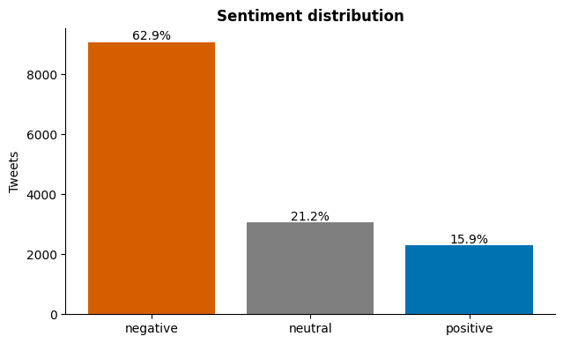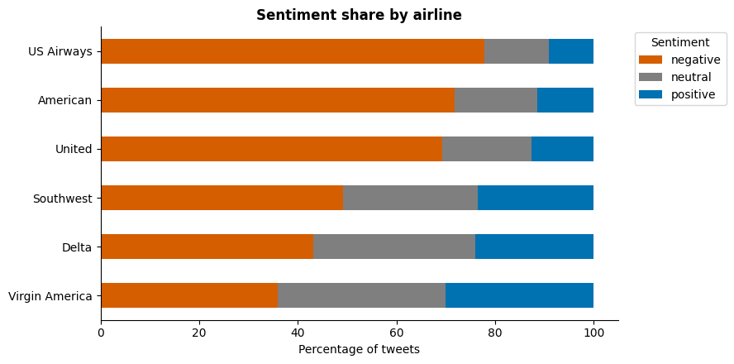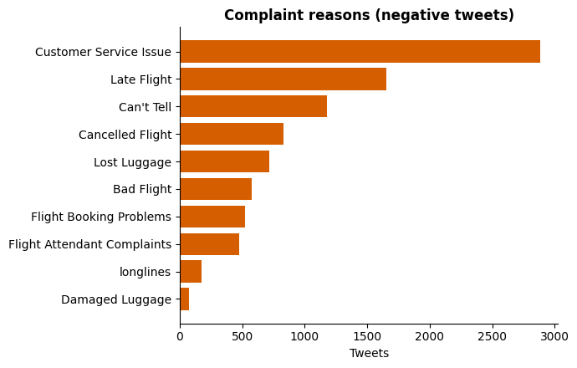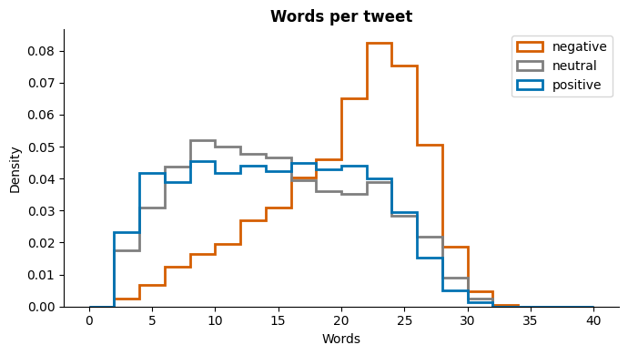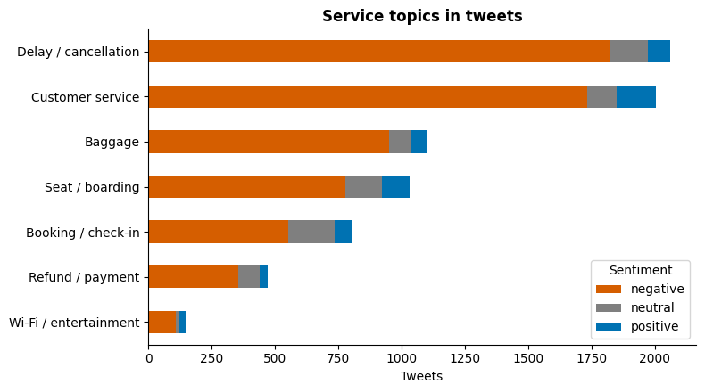

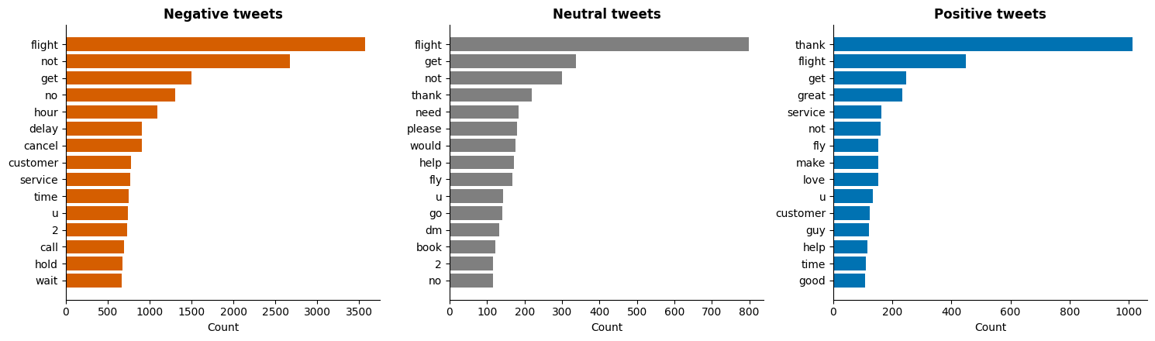

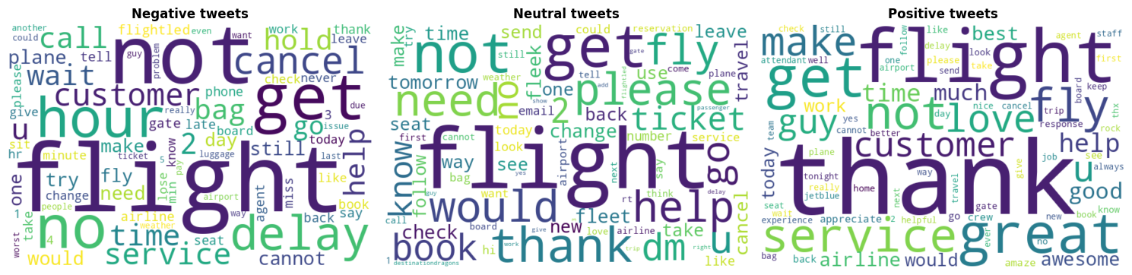

Stop words stay in for every model, because removing them did not help in the experiment above and it can break negation. The two neural models get lightly cleaned text, since they were trained on normal sentences.
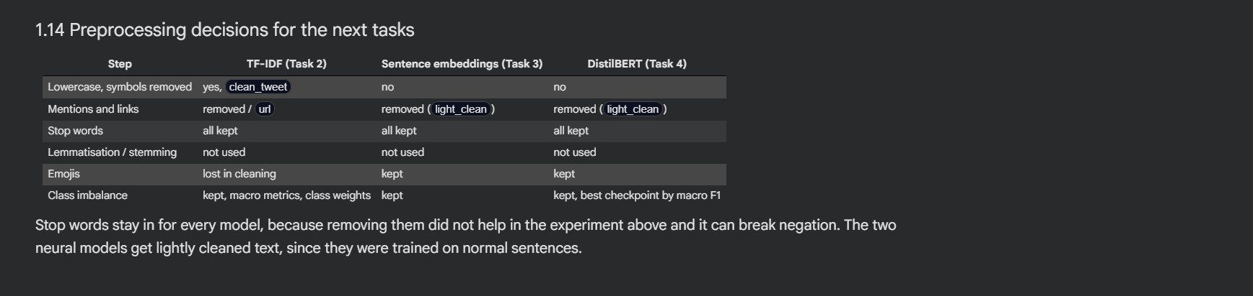

Task 2 : Classical NLP Baseline for Sentiment or Complaint Classification

2.1 Setup and model comparison
We applied a single fixed division consisting of 5,000 tweets (3,000 used for training, 1,000 for validation and 1,000 for testing), maintaining the same class ratio in each of the parts, and Tasks 3 and 4 made use of this split as well. The features employed were the TF-IDF scores for individual words and word pairs (7,375 features), which were learned solely from the training data. The model selected was the one that achieved the highest validation macro F1 score, thus the test set remained unaltered (Grandini, Bagli and Visani, 2020).
The majority reference achieved a macro F1 score of 0.257; Plain Logistic Regression obtained 0.626, even though its accuracy of 0.753 appeared satisfactory since its macro recall was only 0.585 and thus it frequently failed to identify the smaller classes. Class weights corrected most of this problem, and the balanced Logistic Regression reached 0.701, which was better than Linear SVM (0.690) and Complement Naive Bayes (0.633). The impact of the weighting was greater (+0.075) than that of the algorithm choice, which is in line with the finding that models perform poorly on rare classes unless the imbalance is addressed (Henning et al., 2023). However, the difference compared to the SVM (0.011) is too small to be considered significant for 1,000 tweets, so we decided to keep Logistic Regression because of the class probabilities it provides and the ease with which its weights can be read ( Henning et al., 2023).

2.2 Test results
On the test set the balanced Logistic Regression achieved an accuracy of 0.782 and a macro F1 score of 0.724; the various classes did not benefit equally. The F1 score was 0.864 for the negative class, 0.702 for the positive and only 0.605 for the neutral: 538 out of 630 of the negative tweets were correctly classified, but only 131 out of 212 of the neutral ones and 113 out of 158 of the positive ones. The weighted F1 (0.784) is higher since it is influenced by the large number of negative instances, which is why the macro F1 remains our main score. The training time was 0.96 seconds and prediction of 1,000 tweets took 0.053 seconds (Grandini, Bagli and Visani, 2020).

2.3 Error analysis
The model committed 218 errors out of 1,000 tweets and these errors were not distributed equally. In the cases where all the annotators had agreed (728 tweets) the error rate was 15.0%, but for the remaining 272 tweets it was 40.1%. Therefore, the majority of the errors occur in cases where people also hesitate, which lends support to the idea that disagreement usually indicates true ambiguity rather than merely noise (Plank, 2022). The largest number of mistakes were instances where a negative sentiment was interpreted as neutral (66) and where a neutral sentiment was read as negative (56). Complaints about late flights and cancelled flights were seldom overlooked (9.2% and 7.7% respectively), but the model had fewer clues when it came to 'Can't Tell' (32.9%) and booking problems (26.3%).
The following three examples illustrate the model's shortcomings. In the case of Tweet 4254, the user asks "Can you confirm the actual policy?" following a rejection regarding a car seat. All the annotators recognised this as a complaint, yet the model classified it as neutral: it is a polite question containing no emotionally charged words, and the use of "can" and "can you" are among the most indicative of a neutral tone, whereas negative indicators include words such as "not", "hours" and "cancelled". Regarding Tweet 3962 ("yup, it just happens way too often...5 times in the last 12 months"), this is a complaint about a late flight, but none of the words explicitly state this, and since it is a reply, it relies on a message that the model has never seen. In the third instance, a positive tweet ("Kudos to you for excellent customer service!") was given a negative prediction because the label text "Flight Booking Problems" appears within it (tweet 3156), and a bag of words approach cannot realise that this is not the customer's own wording. Identifying such causes is straightforward using a linear model, which is important since more recent models have become less interpretable (Danilevsky et al., 2020).
The entire baseline is at risk because the label text appears in 116 of the test tweets, these achieving an accuracy of 0.871 as compared to 0.770 for the other 884. When the training was repeated without this text, accuracy fell from 0.782 to 0.769 and the macro F1 score dropped from 0.724 to 0.712, meaning that the model makes use of the shortcut only slightly (see notebook section 2.5).

2.4 Optional experiments
The use of the seven yes-or-no NER flags (GPE, ORG, DATE, TIME, MONEY, PERSON, CARDINAL) was of no help, since the validation macro F1 dropped from 0.701 to 0.689; a probable explanation is that entity types provide little information about sentiment, as both happy and angry tweets contain a date or an airline name, and NER is inaccurate on tweets (Ushio et al., 2022). Increasing the amount of data proved to be beneficial. When training was carried out on all 12,427 tweets outside of the validation and test sets, the test macro F1 rose from 0.724 to 0.754 and accuracy increased from 0.782 to 0.803, although the training time rose from 0.96 to 6.48 seconds. This is relevant to Task 4 since DistilBERT only sees the 3,000 training tweets, so part of its shortfall compared to this baseline might be due to the amount of data (Ushio et al., 2022).

2.5 The capabilities and limitations of a classical classifier
In such a feedback system the advantages of this model are speed and transparency; it costs almost nothing to operate, and an analyst can see from the weights that the terms 'hours', 'delayed' and 'cancelled' cause a tweet to be classified as negative, the model having identified 85.4 per cent of the negative tweets. Siino, Tinnirello and La Cascia (2024) state that simple models are able to compete with Transformers when the preprocessing is suited to the data, so this is a reasonable first version and can serve as a baseline for more complex models (Siino, Tinnirello and La Cascia, 2024).
The boundaries are also obvious: the model looks at words and word pairs rather than at their meaning, fails to detect polite or implied complaints, relies on context that it cannot see, and assigns the highest negative weight to the word "not", which might lead to a misinterpretation in the case of a positive tweet such as "not bad at all". Tweets that are neutral remain difficult (with an F1 score of 0.605), and one in three of the "Can't Tell" complaints is missed. While such a classifier is useful for counting and for providing an initial kind of feedback, a person should still examine the cases that are uncertain or of high impact before any action is taken on a single prediction.

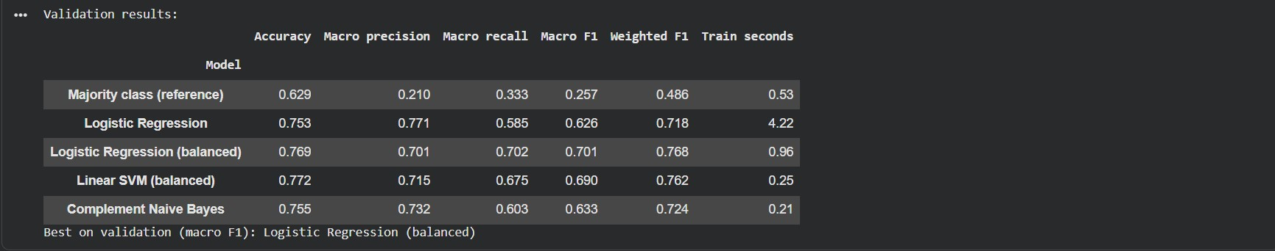

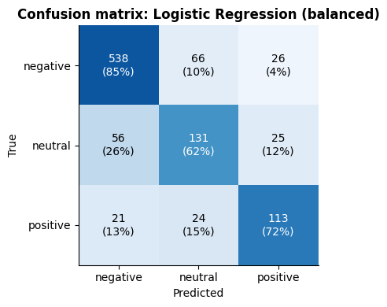
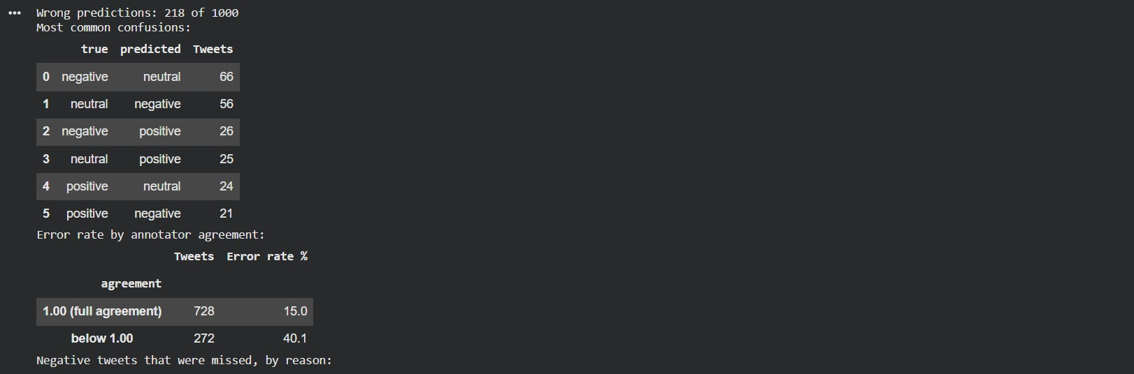

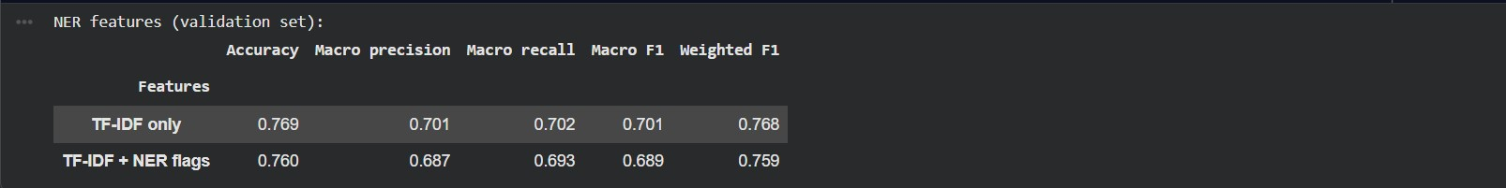

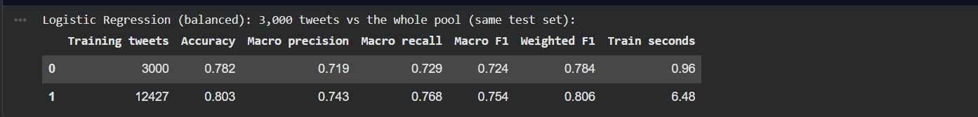

Task 3 : Semantic Embeddings for Feedback Retrieval and Similarity Analysis

3.1 Choosing the embedding model
The total number of tokens in our 14,427 tweets is only about 244,000, which amounts to approximately 17 tokens per tweet, meaning that a Word2Vec model trained on this data would be learning from a very small amount of text, ir means that is not a proper model for small corpus. In a study involving political texts, pre-trained embeddings that were easily available performed either about the same or even better than models that had been trained on the researchers' own corpus (Rodriguez and Spirling, 2022). Since local training was therefore not likely to yield significant results, we decided to use the pre-trained all-MiniLM-L6-v2 model, which converts an entire tweet into a single vector consisting of 384 numbers. This model is part of the MiniLM family, which are compressed Transformers that maintain most of the accuracy of larger models but at a much smaller size. The input text was only slightly cleaned, so negations and emojis were left as they were, and all the tweets were embedded in 9.2 seconds using a GPU (notebook section 3.1; Wang et al., 2020).

3.2 Cosine similarity
The cosine scores have to be examined carefully. Paraphrases received scores ranging from 0.276 to 0.578 and unrelated pairs obtained scores between 0.191 and 0.232, so the ordering is correct, but the gap for 'The customer service was unhelpful' and 'Nobody at the support desk could help me' (0.276) is very small. The highest scores were found for opposite meanings: 0.789 for 'My flight was delayed' versus 'My flight was on time' and 0.741 for a good service against a terrible one. It appears that the vectors capture more the shared topic and wording than they do the degree of meaning agreement, and it is well known that judging similarity using antonyms and negations is difficult (Vahtola, Creutz and Tiedemann, 2022). Therefore, cosine similarity can identify tweets that refer to the same issue, but it is not capable of distinguishing between happy and angry customers (Vahtola, Creutz and Tiedemann, 2022).

3.3 Visualisation
The two principal components account for only 9.6% of the variance, meaning that PCA provides us with very little information. On the t-SNE map, the positive tweets are found towards the right hand side and in a band at the bottom, but they still mix in with the negative ones which occupy the rest of the area. The silhouette score, calculated over all 384 dimensions, is 0.036, nearly zero, so the sentiment does not form any clear groups. The topics, however, appear to be better organised. In the t-SNE analysis of 300 negative tweets for each of the five main reasons for complaint, lost luggage is located in the lower left area, customer service at the top, and late flights on the right, with cancellations situated beside them in the centre, which is reasonable since both of these issues are related to the schedule. The silhouette score remains just 0.028 because the different regions overlap, and therefore we interpret the maps in terms of neighbourhoods rather than in terms of distances between regions. The embeddings capture the topics only loosely and the sentiment almost not at all, something that is in agreement with section 3.2.

3.4 Retrieval
We calculated the cosine similarity for each query and ranked all the tweets accordingly, using a TF-IDF keyword search as a point of comparison. In the case of the query 'customer service was unhelpful', both methods performed well since all five of the semantic results were complaints about customer service and the keyword results were likewise of that type. With respect to the query 'delivery was late', which comes from a different domain, the differences become more apparent. The best match in the semantic search is a tweet that says "sat at MSP for 8 hrs b4 delivery" (0.590), after which come mentions of delayed flights; thus the model associates delivery with delay even though the word 'late' is not used. The keyword search, on the other hand, mainly returned tweets that had the pasted label text 'Late Flight', meaning it identified them by relying on an artifact. Both lists include the positive tweet 'thanks. Delivery status??', showing that topic search requires a sentiment filter. A support team could make use of the semantic list to locate earlier similar cases and replies or to count how frequently certain issues occur, but an agent would still have to check each result.
For six queries the semantic search achieved P@3 and P@5 scores of 0.83 and 0.83, compared to 0.78 and 0.73 for the keyword approach. It succeeded in the case of 'the flight attendant was rude' (scoring 1.00 versus 0.33), but failed on 'the plane left hours after the scheduled time' (0.33 compared to 0.67), likely since the label text is beneficial to the keyword method. Although six queries together with the complaint labels provide a rough indication of relevance, no definite ranking can be established, and BEIR also found that a lexical method such as BM25 constitutes a robust baseline (Thakur et al., 2021).
3.5 Limits and a quick mood test
The method does have certain limitations. The tweets are brief, which means that each vector is based on a limited amount of context. The text is messy, containing typos, mentions, and copied label strings. The classes are unbalanced (62.9% negative), so the neighbours of nearly every complaint are negative and there are few neighbours for rare topics. Also, the model was not designed for airline language.
For an additional test we trained a balanced Logistic Regression using the frozen vectors. On the test set it achieved a macro F1 score of 0.734 and an accuracy of 0.778, compared to 0.724 and 0.782 for TF-IDF as seen in Task 2. A difference of 0.010 is not significant at all on the basis of 1,000 tweets, but the profile does change: the recall for neutral increased from 0.618 to 0.731, while that for negative decreased from 0.854 to 0.802. Hence the vectors do a better job of separating topics than they do with regard to sentiment, which creates an opportunity for Task 4, in which the model is trained on the labels themselves.

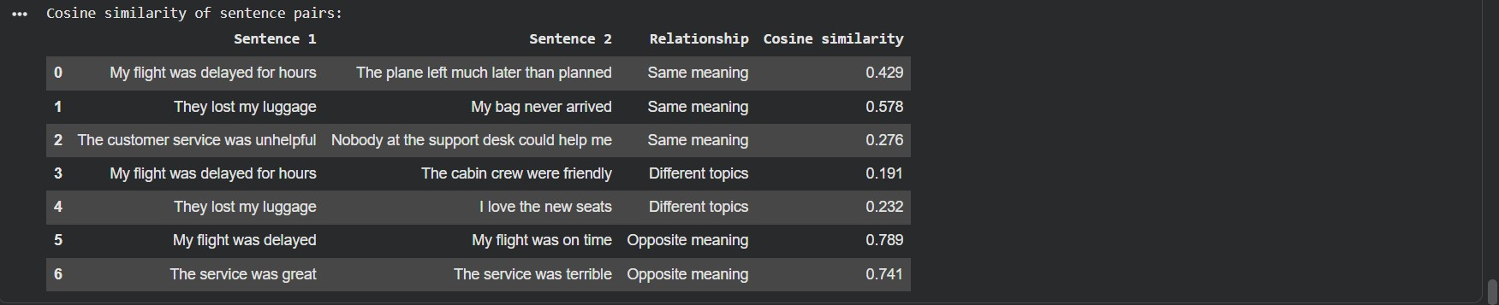

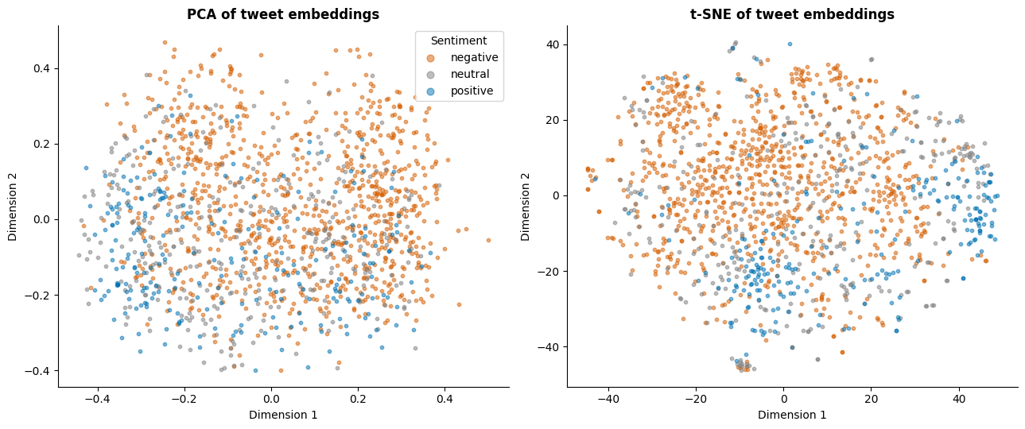

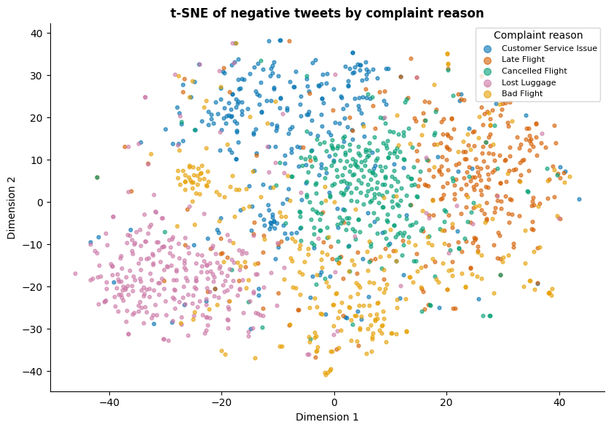

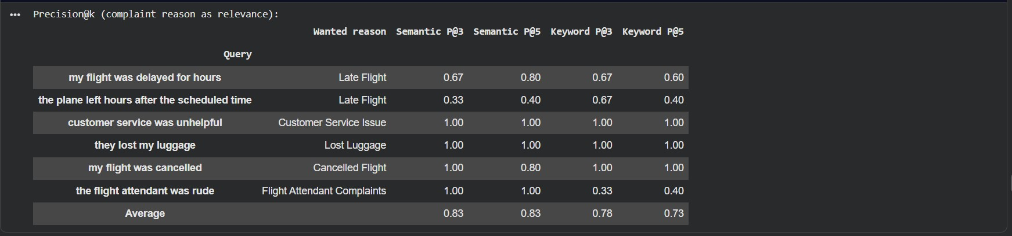

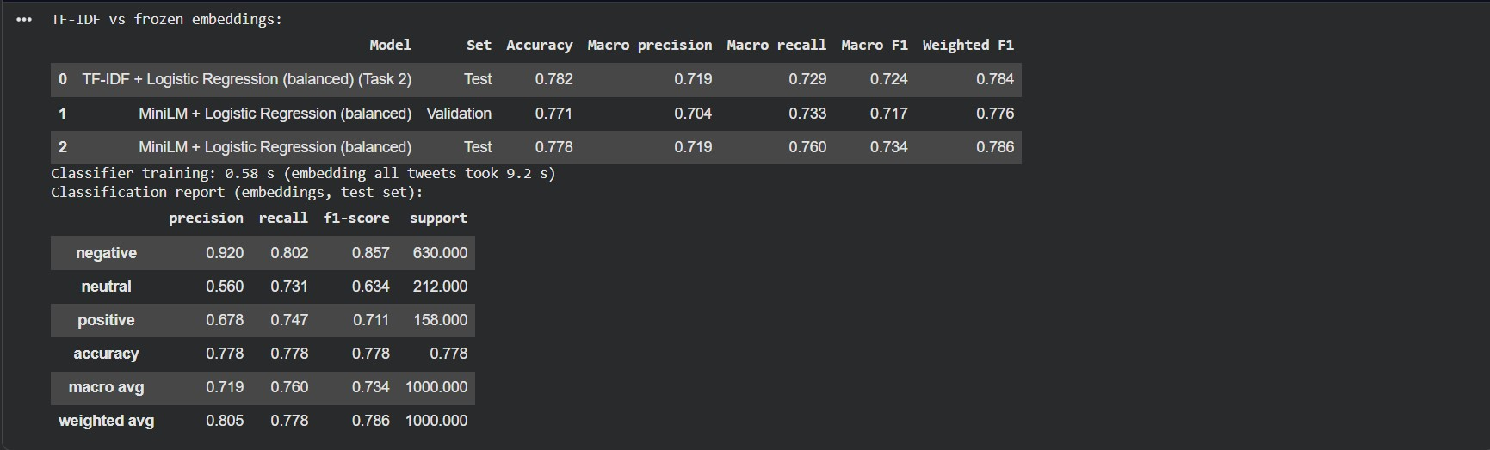

Task 4 : Fine Tuning a Transformer for Sentiment or Feedback Classification

4.1 Setup and training
We fine-tuned DistilBERT, a small Transformer model which can be run on a free Colab GPU, using the same 3,000 training tweets as in Task 2, together with the same validation and test tweets. We employed the standard settings (a learning rate of 2e-5, a batch size of 16, and up to 10 epochs) and selected the epoch on the basis of the validation macro F1, since accuracy tends to favour the large negative class. The best epoch was the second one (with a validation macro F1 of 0.760); afterwards the validation loss increased from 0.49 to 1.01, while the macro F1 remained between 0.73 and 0.76, indicating that the model was still fitting the training tweets without making any improvement on unseen data and that most of the 206 seconds of training time had therefore been wasted. We used only one random seed, and other seeds might lead to different results (Mosbach, Andriushchenko and Klakow, 2021(.

4.2 The results of the test and a comparison with Task 2
In the test set DistilBERT achieved an accuracy of 0.825 and a macro F1 score of 0.774, as compared to the Task 2 baseline which obtained 0.782 and 0.724. The F1 score for the positive class increased the most (from 0.702 to 0.773) while that for the neutral class rose the least (from 0.605 to 0.657), meaning that the neutral class remains the weakest. The two models differed in 179 tweets and DistilBERT was correct in 111 of these (exact McNemar test, p = 0.0016), so the improvement is not due to chance. That said, the comparison has to be made with care. The baseline, having been trained on 12,427 tweets, attained a macro F1 of 0.754 in Task 2, which is only 0.020 below the figure achieved by DistilBERT, who was trained on 3,000 tweets. When the amount of data is the same, the difference is 0.050, but DistilBERT was not trained on the full dataset, so we cannot determine how big the gap would be if that had happened.

Table 2. TF-IDF baseline and fine-tuned DistilBERT on the same 1,000 test tweets.
Criterion | TF-IDF + Logistic Regression | Fine-tuned DistilBERT
Accuracy / macro F1 | 0.782 / 0.724 | 0.825 / 0.774
Training time | 1.0 s | 206.3 s on a GPU (10 epochs)
Prediction, 1,000 tweets | 0.05 s | 0.49 s on a GPU
Parameters | 22,128 | 66,955,779
Memory | Small | 1.46 GB peak GPU memory in training
Interpretability | Word weights can be read | Only a probability per class
Deployment | Simple linear model | Larger model, GPU advised (CPU speed not measured)

Although the costs appear high when looked at relatively—since the model has about 3,000 times more parameters, 200 times more training time, and is 10 times slower at making predictions—in absolute terms processing 1,000 tweets takes less than half a second, so for a team that scores thousands of tweets each day speed is not an issue. What is lost, however, is transparency: the baseline model shows that both 'hours' and 'cancelled' have the effect of making a tweet more negative, whereas DistilBERT only provides a probability, which supports the concern that more powerful models are harder to interpret (Danilevsky et al., 2020). Simple models are able to perform well when the preprocessing is appropriate (Siino, Tinnirello and La Cascia, 2024), and our baseline almost achieved the same result with more data, so the improvement of 0.020 to 0.050 must be balanced against this loss (Table 2; Siino, Tinnirello and La Cascia, 2024).

4.3 Error patterns and level of confidence
In seven out of the eight reasons we examined, DistilBERT missed fewer complaints. The number of "Can't Tell" complaints dropped from 32.9% to 19.5% and that for cancellations from 7.7% to 3.1%. Regarding lost luggage the figure got worse (11.5% to 15.4%), but this is only 6 out of 52 tweets, so it isn't significant enough to draw any firm conclusions. Both models made errors in 107 tweets. Negation still leads to misinterpretation: the positive tweet "we don't need anybody else!" was classified as negative with a confidence level of 0.881. All of the four most confident mistakes (ranging from 0.957 to 0.975) are marked as neutral, and in some cases—such as a passenger who is hoping for a safe flight while the plane is being de-iced again—the situation could reasonably be considered negative. Therefore, part of the error is due to the ambiguous labels and not to the model (Plank, 2022; notebook section 4.8).
It does make a difference. For correct predictions the average confidence level was 0.889 and for incorrect ones it was 0.727, consistent with the result that pre-trained Transformers are fairly well calibrated when dealing with data similar to their training data (Desai and Durrett, 2020). If all tweets with a confidence level below 0.8 were sent to a human, then 75.0% could be handled automatically with an accuracy of 91.1% and 61.7% of the errors would be picked up, although 250 tweets, one quarter of the total, would still need to be reviewed. When the threshold is set at 0.9, 56.6% remain to be processed automatically (with an accuracy of 0.947) and 82.9% of the errors are caught. The choice of threshold is a business decision involving the review workload and the number of errors that are acceptable (Desai and Durrett, 2020).

4.4 Practical implications
When it comes to resources, the cost of training is low but each prediction requires all 67 million parameters to be kept in memory. Models that have been compressed, such as MiniLM, have been developed since large Transformers encounter limitations in terms of latency and capacity (Wang et al., 2020). With regard to reliability, a single test set can give an overestimate of how a model will perform on new data, and behavioural tests have identified serious failures even in commercial sentiment models (Ribeiro et al., 2020). Our negation errors are a case in point. On the issue of fairness, airline and sentiment are connected in the data (77.8% of the tweets about US Airways are negative compared to 43.2% for Delta), which is why the results need to be examined on a per-airline basis, as Task 5 requires. As for monitoring, DistilBERT labels 65.3% of all tweets as negative compared to 62.9% in the human labels; this is an inexpensive figure to monitor using confidence levels and by regularly checking a sample of tweets with human verification, in order to detect drift or new problems such as the pasted label text early (notebook Extension section; Ribeiro et al., 2020).

4.5 Extension: sentiment-aware retrieval
In the case shown in 3.2 the sentences were similar, which meant that a search for "The service was great" could end up returning complaints. To correct this we took the 50 most similar tweets, retained only those that DistilBERT predicted had the desired sentiment and then returned the first five. Over the course of eight queries the proportion of correct top-five results increased from 0.82 to 0.88, and for the phrase "The service was great" the number of correct results went from 4 to 5 since with a simple search "terrible service" had appeared second. With respect to "My flight was on time" only one of the 50 candidates was positive, so the filter returned just one tweet: it is able to eliminate incorrect results but cannot add in the ones that are missing. Since DistilBERT was trained on one fifth of these tweets and only eight queries were used, the improvement is only slight.
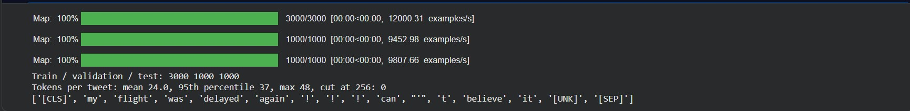

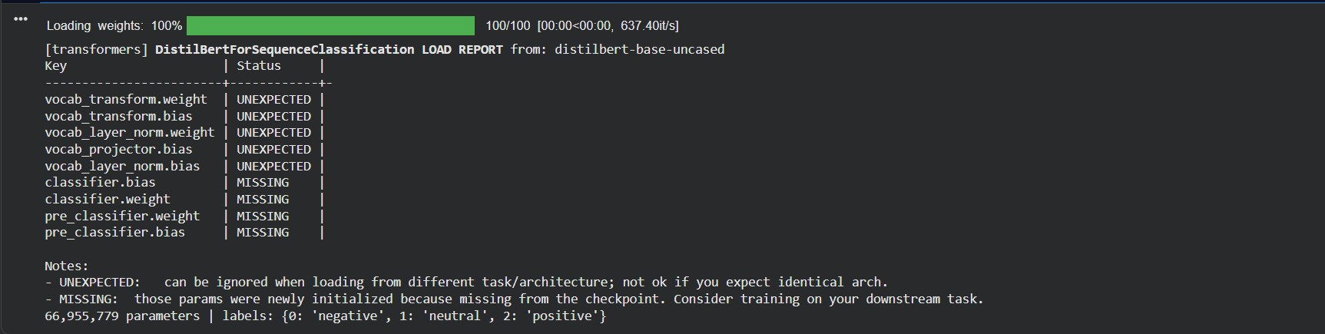

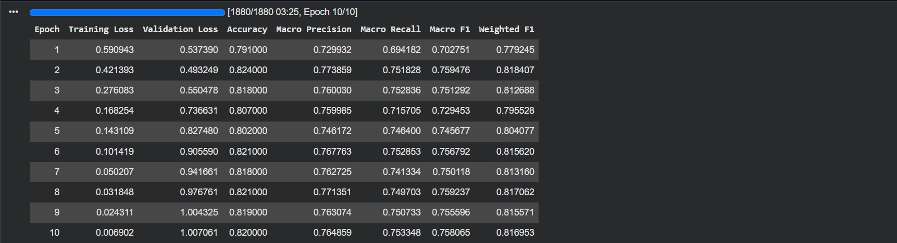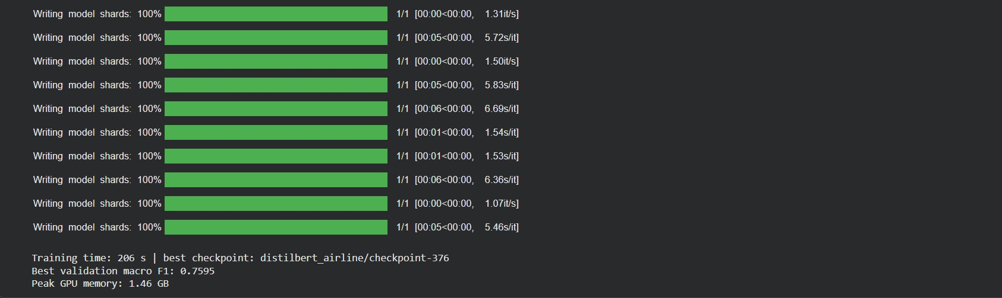
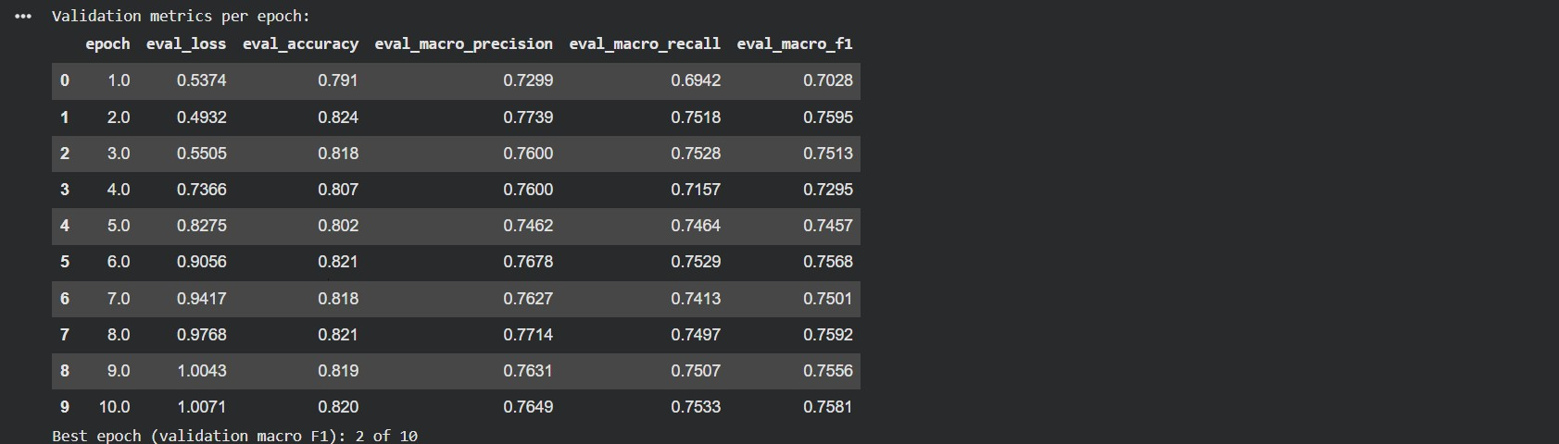

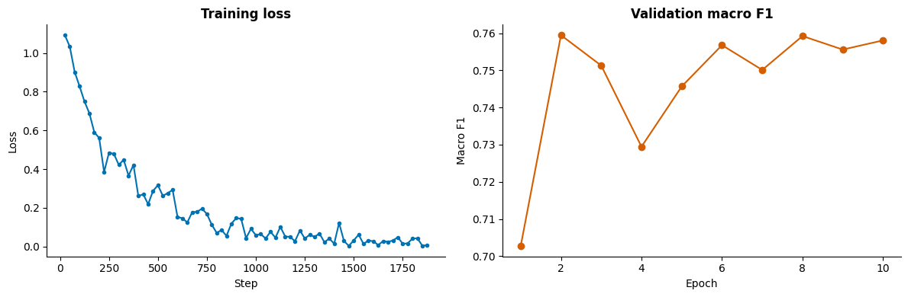

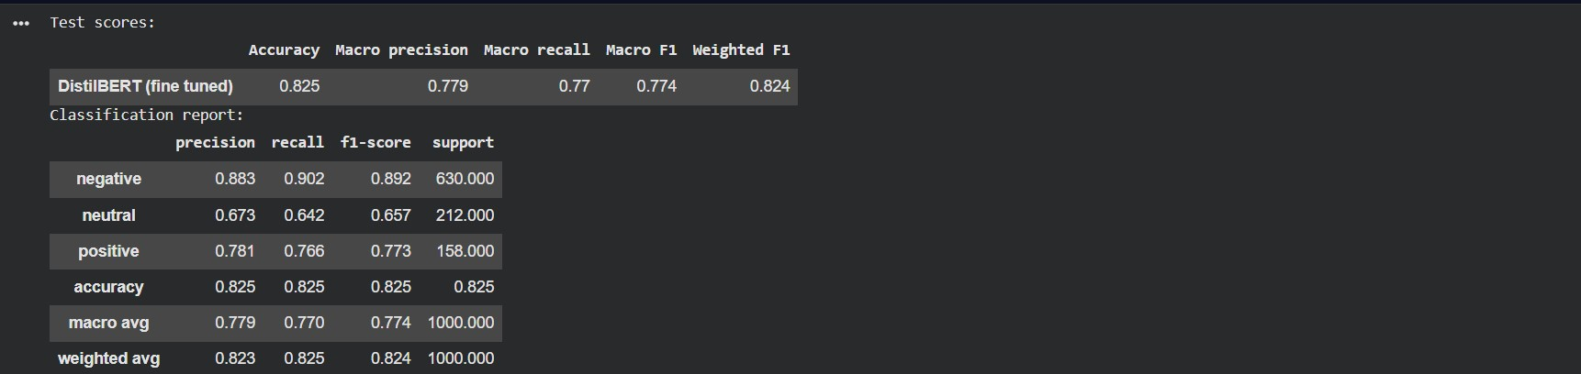
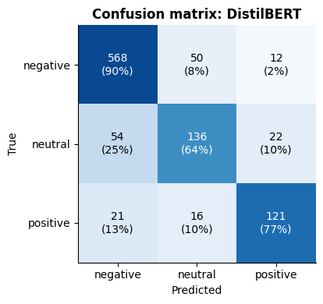

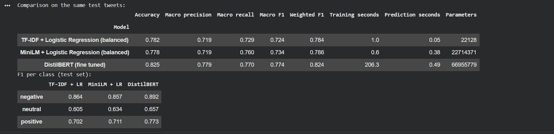

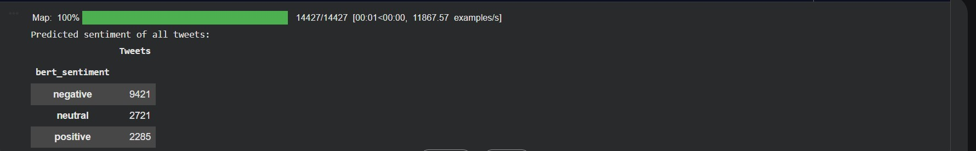

Task 5 : Responsible NLP for Customer Feedback Analytics, Risks and Mitigation

5.1 Bias and unequal results across airlines
Since there is no demographic information available, we use the airline to represent the different customer groups. The results are clearly different. The proportion of negative tweets ranges from 33.8% for Delta to 78.0% for US Airways, and the Task 2 baseline is least accurate when it comes to Delta (with a value of 0.683 compared to 0.834 for US Airways). Although DistilBERT reduces the gap, it still over-predicts the number of negative tweets for Delta (40.8% rather than 33.8% in the labels) and for Southwest (50.0% rather than 42.9%). Therefore, a dashboard would show the difference between Delta and US Airways as 36.3 points rather than the actual 44.2. Accuracy also masks some problems: United achieves a score of 0.804 but has the lowest macro F1 (0.699), which may be due to the fact that only a quarter of its 271 test tweets are not negative. Bias has many origins, and fairness needs to be examined for the groups that are important (Mehrabi et al., 2021). One possible reason for this could be the quality of the labels, since neutral tweets showed the lowest level of agreement among the annotators in Task 1 )Mehrabi et al., 2021).

5.2 The need to address complaints promptly and the consequences of failing to do so
According to our own criteria, 277 out of the 630 test complaints are classified as urgent—these include cancelled and late flights, lost or damaged luggage, and booking problems. DistilBERT failed to identify 26 of them (9.4%) and the Task 2 baseline missed 34 (12.3%). The number of misses is not even: DistilBERT missed 18.4% of the booking problems and 15.4% of the lost-luggage complaints, but only 6.7% of the late flights and 3.1% of the cancellations, so the cases that require the most assistance are the ones that are covered the worst. A lower alert threshold on P(negative) results in more urgent complaints being detected. Reducing the threshold from 0.5 to 0.2 increases the proportion of urgent complaints found from 89.9% (which is only slightly more stringent than the default decision mentioned above) to 96.4%, an increase of about 18, but it also flags an additional 55 of the 370 non-complaints, meaning that for each extra urgent complaint found there are roughly three false alarms. When the threshold is lowered further to 0.1, only 8 more urgent tweets are identified, at the cost of an additional 57 false alarms and as a result 80.2% of all tweets are flagged, which makes the whole triage process pointless. The appropriate threshold is a business decision that has to balance agent time against unhappy customers.
5.3 Privacy, abusive language and excessive dependence
Email addresses (0.1%) and phone numbers (0.2%) are uncommon, but 10.8% of the tweets refer to more than one account and spaCy identifies a person's name in 8.5% of cases. However, this figure is too high since spaCy treated the airport code JFK as a person name about 136 times in Task 1. It is difficult to anonymise free-text data because one has to strike a balance between the risk of disclosure and the usefulness of the data (Lison et al., 2021); therefore, the safer approach is to mask any mentions, names, and links before the tweets are stored or indexed. Abusive words are mainly found in complaints: 309 negative tweets (3.4%) include a word from our short list, as compared with 0.3% of the neutral and positive ones. In the test set, the 28 abusive tweets are 92.9% negative, and DistilBERT correctly classified 89.3% of them whereas it achieved 82.3% accuracy for the others. Rude wording is a strong indicator, not a difficulty, yet 28 tweets show only a small effect.
The greatest risk is over-reliance. If action is taken in response to every prediction, then 17.5% of the tweets will involve a wrong decision and the dashboard will show 65.3% negative compared to 62.9% in the actual labels. In Task 4, human review when the confidence level is below 0.8 would identify 61.7% of the errors among 250 of the 1,000 tweets, and that is precisely what human-in-the-loop systems are designed for (Mosqueira-Rey et al., 2023). The EU AI Act mandates human oversight for high-risk systems. Although service monitoring is not included among the high-risk areas, assessing employees based on their complaint scores could shift it into the employment sector. We have not carried out any legal evaluation and would still maintain human oversight (European Parliament and Council, 2024).

5.4 Trend: retrieval-augmented generation
Retrieval-augmented generation (RAG) works by first retrieving relevant texts and then having a language model generate its answer based on those. It was suggested as a way of giving models provenance and access to updatable knowledge (Lewis et al., 2020), and surveys describe it as a solution to the problems of hallucination, outdated knowledge and untraceable reasoning in large language models (Gao et al., 2024). If a team wanted feedback analytics, it could find out what people have said about lost bags this week and receive a brief summary together with the tweets that underlie it. This would assist with summarisation, service quality monitoring and complaint routing, and all that would need to be done would be to add the new tweets to the index, with no need for retraining (Gao et al., 2024).
The results show that retrieval achieved half the success. In Task 3, semantic search produced 0.83 correct results out of five, compared with 0.73 for keyword search, and in Task 4 the sentiment filter increased the figure from 0.82 to 0.88. Although the generator works by producing text based on what is retrieved, even when the rate has reached 0.88 one in eight of the results is still incorrect. With regard to the example "The service was great", plain search listed "terrible service" as the second result.

RAG has certain limitations; seven specific points of failure have been identified, ranging from missing content to incomplete answers, and a RAG system can only be tested as it is running (Barnett et al., 2024). Furthermore, the models tend to handle long inputs in an uneven manner and perform most poorly when it comes to information in the middle (Liu et al., 2024), a factor that is important when it is necessary to summarise hundreds of tweets. Evaluation is difficult since our precision check makes use of complaint labels as a very rough substitute, whereas more recent tools assess both the context and the answer without referring to human-generated answers (Es et al., 2024). Although large language models perform well on simple sentiment tasks and when only a small number of labels are available, they fall behind on more difficult tasks (Zhang et al., 2024).
In practice, RAG should be used for exploring and summarising the feedback, not for counting or making decisions. The figures such as the percentage of negative tweets should still be obtained from the classifier with the checks mentioned above, since a summary generated by the system can appear certain even if it is incorrect. Each sentence in the summary must be linked to its corresponding source tweets, the private data from 5.3 should have the sensitive information masked before it is indexed, and there should be human review at the stage between retrieval and any decision. Although used in this way, RAG could help to speed up the process of gaining insights, but it does introduce a stage that itself has to be monitored (Gao et al., 2024; Mosqueira-Rey et al., 2023).

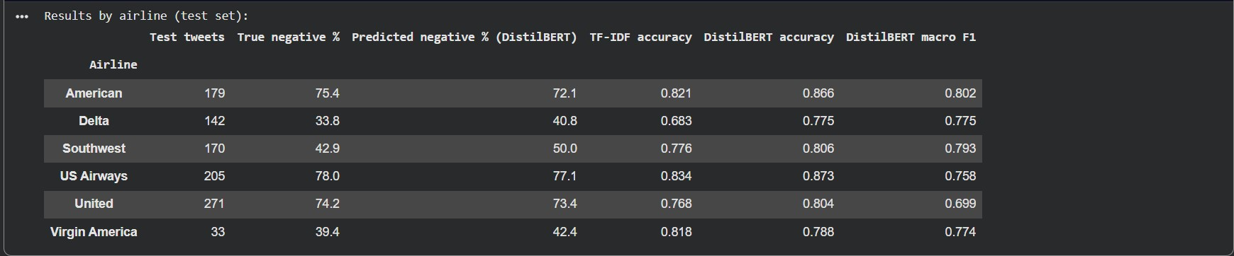

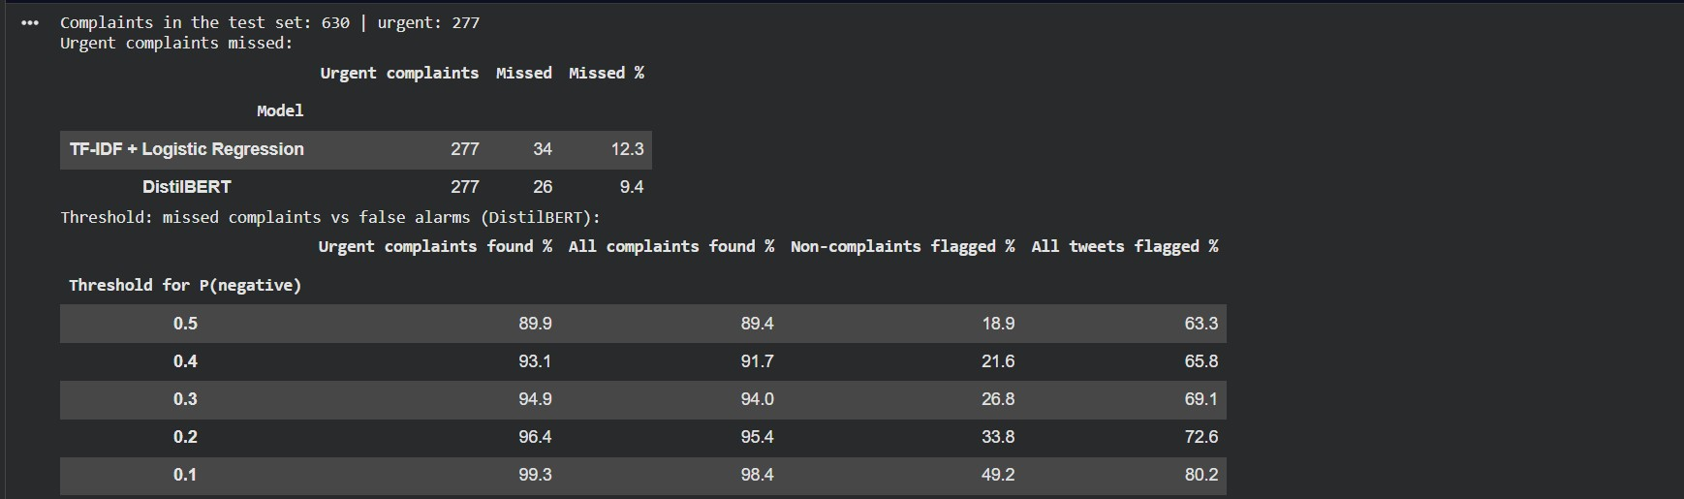

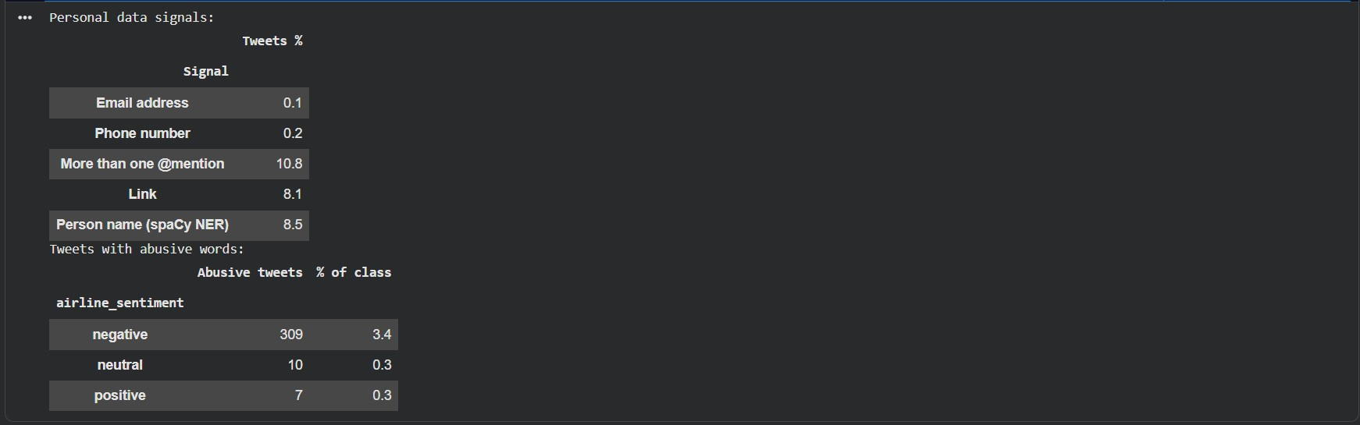

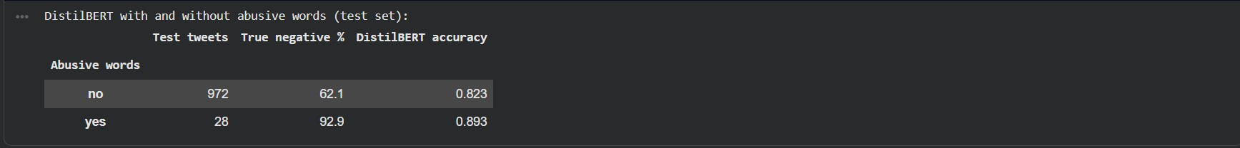

Conclusion

The findings indicate that each method should be used for the purpose it is best suited to. The fine-tuned DistilBERT was the most accurate model (achieving a macro F1 score of 0.774 compared to 0.724 for the TF-IDF baseline), and this improvement is very unlikely to be due to chance, although the baseline, which was trained on about four times as many tweets, was only 0.020 away and was also much cheaper and easier to read. The sentence embeddings were able to identify complaints relating to the same topic but could not distinguish between happy and angry customers, so it is necessary to use a sentiment filter when carrying out searches. Preprocessing also made a difference, at least in part because of the way negations were handled, and the majority of the errors occurred in the areas where the annotators had disagreed.
The risks are practical since the results varied from airline to airline, DistilBERT failed to identify 9.4% of the urgent complaints, and when the alert threshold was lowered from 0.5 to 0.2, about 18 more of these cases were detected but this also led to about 55 additional false alarms. An appropriate system would use the classifier, carry out further investigation using semantic search or RAG, adjust the thresholds on the basis of cost and send tweets with low confidence to a human being. Based on a single split, one seed and 1,000 test tweets, these results are only strong indications and not definitive proof.

References

Barnett, S., Kurniawan, S., Thudumu, S., Brannelly, Z. and Abdelrazek, M. (2024) 'Seven failure points when engineering a retrieval augmented generation system', CAIN 2024: 3rd International Conference on AI Engineering, Lisbon, Portugal. arXiv:2401.05856.
CrowdFlower (n.d.) Twitter US Airline Sentiment [Dataset]. Kaggle. Available at: https://www.kaggle.com/datasets/crowdflower/twitter-airline-sentiment
Danilevsky, M., Qian, K., Aharonov, R., Katsis, Y., Kawas, B. and Sen, P. (2020) 'A survey of the state of explainable AI for natural language processing', Proceedings of the 1st Conference of the Asia-Pacific Chapter of the Association for Computational Linguistics and the 10th International Joint Conference on Natural Language Processing, pp. 447–459. doi:10.18653/v1/2020.aacl-main.46.
Desai, S. and Durrett, G. (2020) 'Calibration of pre-trained transformers', Proceedings of the 2020 Conference on Empirical Methods in Natural Language Processing (EMNLP), pp. 295–302. doi:10.18653/v1/2020.emnlp-main.21.
Elangovan, A., He, J. and Verspoor, K. (2021) 'Memorization vs. generalization: quantifying data leakage in NLP performance evaluation', Proceedings of the 16th Conference of the European Chapter of the Association for Computational Linguistics: Main Volume, pp. 1325–1335. doi:10.18653/v1/2021.eacl-main.113.
Es, S., James, J., Espinosa Anke, L. and Schockaert, S. (2024) 'RAGAs: automated evaluation of retrieval augmented generation', Proceedings of the 18th Conference of the European Chapter of the Association for Computational Linguistics: System Demonstrations, pp. 150–158. doi:10.18653/v1/2024.eacl-demo.16.
European Parliament and Council (2024) Regulation (EU) 2024/1689 of 13 June 2024 laying down harmonised rules on artificial intelligence (Artificial Intelligence Act). Official Journal of the European Union. Available at: https://eur-lex.europa.eu/eli/reg/2024/1689/oj (Accessed: [date]).
Gao, Y., Xiong, Y., Gao, X., Jia, K., Pan, J., Bi, Y., Dai, Y., Sun, J., Wang, M. and Wang, H. (2024) 'Retrieval-augmented generation for large language models: a survey'. arXiv:2312.10997 [preprint].
Grandini, M., Bagli, E. and Visani, G. (2020) 'Metrics for multi-class classification: an overview'. arXiv:2008.05756 [preprint].
Henning, S., Beluch, W., Fraser, A. and Friedrich, A. (2023) 'A survey of methods for addressing class imbalance in deep-learning based natural language processing', Proceedings of the 17th Conference of the European Chapter of the Association for Computational Linguistics, pp. 523–540. doi:10.18653/v1/2023.eacl-main.38.
Lewis, P., Perez, E., Piktus, A., Petroni, F., Karpukhin, V., Goyal, N., Küttler, H., Lewis, M., Yih, W., Rocktäschel, T., Riedel, S. and Kiela, D. (2020) 'Retrieval-augmented generation for knowledge-intensive NLP tasks', Advances in Neural Information Processing Systems, 33, pp. 9459–9474.
Lison, P., Pilán, I., Sánchez, D., Batet, M. and Øvrelid, L. (2021) 'Anonymisation models for text data: state of the art, challenges and future directions', Proceedings of the 59th Annual Meeting of the Association for Computational Linguistics and the 11th International Joint Conference on Natural Language Processing (Volume 1: Long Papers), pp. 4188–4203. doi:10.18653/v1/2021.acl-long.323.
Liu, N.F., Lin, K., Hewitt, J., Paranjape, A., Bevilacqua, M., Petroni, F. and Liang, P. (2024) 'Lost in the middle: how language models use long contexts', Transactions of the Association for Computational Linguistics, 12, pp. 157–173. doi:10.1162/tacl_a_00638.
Mehrabi, N., Morstatter, F., Saxena, N., Lerman, K. and Galstyan, A. (2021) 'A survey on bias and fairness in machine learning', ACM Computing Surveys, 54(6), article 115. doi:10.1145/3457607.
Mosbach, M., Andriushchenko, M. and Klakow, D. (2021) 'On the stability of fine-tuning BERT: misconceptions, explanations, and strong baselines', Proceedings of the 9th International Conference on Learning Representations (ICLR 2021). arXiv:2006.04884.
Mosqueira-Rey, E., Hernández-Pereira, E., Alonso-Ríos, D., Bobes-Bascarán, J. and Fernández-Leal, Á. (2023) 'Human-in-the-loop machine learning: a state of the art', Artificial Intelligence Review, 56(4), pp. 3005–3054. doi:10.1007/s10462-022-10246-w.
Nguyen, D.Q., Vu, T. and Nguyen, A.T. (2020) 'BERTweet: a pre-trained language model for English Tweets', Proceedings of the 2020 Conference on Empirical Methods in Natural Language Processing: System Demonstrations, pp. 9–14. doi:10.18653/v1/2020.emnlp-demos.2.
Palomino, M.A. and Aider, F. (2022) 'Evaluating the effectiveness of text pre-processing in sentiment analysis', Applied Sciences, 12(17), article 8765. doi:10.3390/app12178765.
Plank, B. (2022) 'The "problem" of human label variation: on ground truth in data, modeling and evaluation', Proceedings of the 2022 Conference on Empirical Methods in Natural Language Processing, pp. 10671–10682. doi:10.18653/v1/2022.emnlp-main.731.
Ribeiro, M.T., Wu, T., Guestrin, C. and Singh, S. (2020) 'Beyond accuracy: behavioral testing of NLP models with CheckList', Proceedings of the 58th Annual Meeting of the Association for Computational Linguistics, pp. 4902–4912. doi:10.18653/v1/2020.acl-main.442.
Rodriguez, P.L. and Spirling, A. (2022) 'Word embeddings: what works, what doesn't, and how to tell the difference for applied research', The Journal of Politics, 84(1), pp. 101–115. doi:10.1086/715162.
Sarica, S. and Luo, J. (2021) 'Stopwords in technical language processing', PLOS ONE, 16(8), e0254937. doi:10.1371/journal.pone.0254937.
Siino, M., Tinnirello, I. and La Cascia, M. (2024) 'Is text preprocessing still worth the time? A comparative survey on the influence of popular preprocessing methods on Transformers and traditional classifiers', Information Systems, 121, article 102342. doi:10.1016/j.is.2023.102342.
Thakur, N., Reimers, N., Rücklé, A., Srivastava, A. and Gurevych, I. (2021) 'BEIR: a heterogeneous benchmark for zero-shot evaluation of information retrieval models', Proceedings of the Neural Information Processing Systems Track on Datasets and Benchmarks (NeurIPS 2021). arXiv:2104.08663.
Ushio, A., Barbieri, F., Sousa, V., Neves, L. and Camacho-Collados, J. (2022) 'Named entity recognition in Twitter: a dataset and analysis on short-term temporal shifts', Proceedings of the 2nd Conference of the Asia-Pacific Chapter of the Association for Computational Linguistics and the 12th International Joint Conference on Natural Language Processing (Volume 1: Long Papers), pp. 309–319. doi:10.18653/v1/2022.aacl-main.25.
Vahtola, T., Creutz, M. and Tiedemann, J. (2022) 'It is not easy to detect paraphrases: analysing semantic similarity with antonyms and negation using the new SemAntoNeg benchmark', Proceedings of the Fifth BlackboxNLP Workshop on Analyzing and Interpreting Neural Networks for NLP, pp. 249–262. doi:10.18653/v1/2022.blackboxnlp-1.20.
Wang, W., Wei, F., Dong, L., Bao, H., Yang, N. and Zhou, M. (2020) 'MiniLM: deep self-attention distillation for task-agnostic compression of pre-trained transformers', Advances in Neural Information Processing Systems, 33, pp. 5776–5788.
Zhang, W., Deng, Y., Liu, B., Pan, S. and Bing, L. (2024) 'Sentiment analysis in the era of large language models: a reality check', Findings of the Association for Computational Linguistics: NAACL 2024, pp. 3881–3906. doi:10.18653/v1/2024.findings-naacl.246.

APPENDIX (if necessary)

Project Link on Github: Link
Twitter US Airline Sentiment dataset Link on Kaggle : Link

